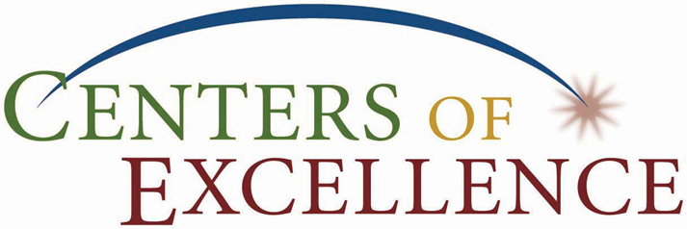
Centers of Excellence Director Meeting
I.C. Chair – John Martens, VPI, Centralia College
September 14, 2011,
Centralia College 2-4pm
Introductions – Barbara Hins-Turner

Center Overviews:

Maureen Majury, 2011/12 COE Chair, Information and Computing – Program Reviews

Mike Campbell, Homeland Security – Dacum Career Clusters Soft Skills

Shana Peschek, Construction -

Ann Avary, Marine Manufacturing -

Pat Ward, SBCTC Update

Maureen Majury – COE Assessment Process

Washington State Centers of Excellence:

Aerospace and Advanced Materials Mfg – Everett Community College
Allied Health – Yakima Valley Community College
Agriculture – Walla Walla Community College
Construction e – Renton Technical College
Clean Energy - Centralia College
Education – Green River Community College
Homeland Security – Pierce College
Information and Computing Technology – Bellevue College
International Trade, Transportation and Logistics – Green River Community College
Marine Manufacturing – Skagit Valley College

COE - Consolidated web site
http://www.coewa.com/

