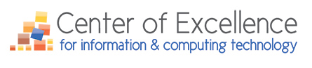

Updates & News for August 2017

The Center of Excellence for Information Technology is offering up to 10 IT Professional Development Training Scholarships to CTC IT Faculty across Washington State
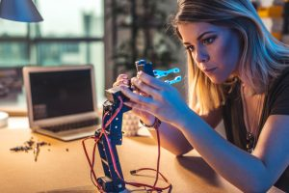

There is a rotating deadline for the IT faculty professional development training scholarship applications:
- The first deadline will be September 13, 2017, with a decision made by September 15, 2017, for the up to four recipients.
- The second deadline will be November 3, 2017, for up to three recipients, with a decision made by November 8, 2017 (note: those who submitted for the September 13, 2017, deadline do not need to resubmit).
- The final deadline will be January 11, 2018, for up to three recipient (note: those who submitted for the first two application submission deadlines do not need to resubmit). The decision will be made by January 16, 2018.

IT Professional Development must take place between October 5, 2017 and May 10, 2018.

The following are examples of the types of IT professional development training opportunities IT faculty could consider, if they don’t already have a training opportunity in mind.
- ACCELERATE, October 16-18, 2017, Seattle, WA (Machine Learning and Robotics)
- IBM’s THINK 2018, March 19-22, 2018, Las Vegas, NV
- Red Hat Summit, May 8-10, 2018, San Francisco, CA (Registrations open in early 2018)
- Microsoft Ignite, 2018 (Dates not finalized), USA

NOTE: Online or local in-person training is also an option for those who don’t want to attend a professional development or training conference.

Click here for process details and how to apply.

Bellevue College to Launch New Degree in Robotics and Artificial Intelligence

The Center has spent extensive time researching emerging/disruptive technology trends that will have a direct impact on IT programs across the state. Based upon the large number of technology jobs that work with robotics, artificial intelligence (AI), machine learning, and predictive analytics, there is a need for a community or technical college to create a degree to address this demand. The Center has been working on creating a degree to meet this workforce need and skills gap with Bellevue College (BC). Since 2016, it has been building an updated, interdisciplinary robotics and AI program. A special topics overview robotics and AI programming course took place Spring Quarter 2017. This first step, to begin the structure for a new course offering, ultimately sets the stage for the end-goal of full development and implementation of a robotics and AI degree. The AAST will launch fall 2018, and the BAS is expected to launch in 2018.

There is an urgent need for technology workers across all industry sectors that understand and can apply for jobs in Robotics, AI, Machine Learning, and Predictive Analytics. Job posting searches over the last year and one-half indicate demand in the following areas: Machine Learning (1,457), Robotics (210), Artificial Intelligence (86), and Predictive Modeling (146).

According to many industry observers, we are today on the cusp of a Fourth Industrial Revolution. Developments in previously disjointed fields such as artificial intelligence and machine learning, robotics, nanotechnology, 3D printing and genetics and biotechnology are all building on and amplifying one another. Smart systems—homes, factories, farms, grids or entire cities—will help tackle problems ranging from supply chain management to climate change. Concurrent to this technological revolution are a set of broader socio-economic, geopolitical and demographic developments, each interacting in multiple directions and intensifying each another. (Source: The Future of Jobs, Employment, Skills and Workforce Strategy for the Fourth Industrial Revolution)

IT Futures Summit: 2017
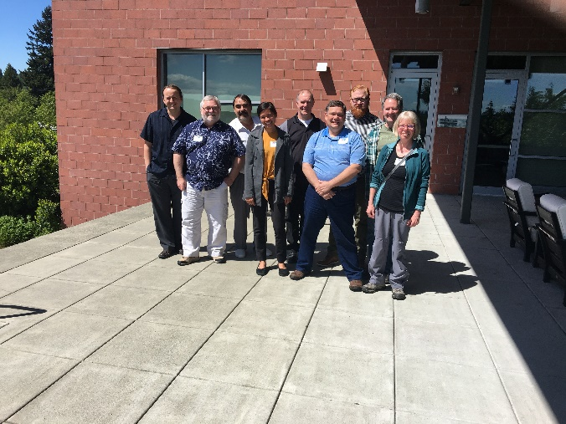
From left to right our IT Jeopardy Winners
- Arthur Wanner, Big Bend Community College, Computer Science
- Steve Simpson, Tacoma Community College, Networking & Cyber Security
- Gerald Sampson, Walla Walla Community College, Computer Science
- Veronica Waterman, Tacoma Community College, Networking & Cyber Security
- Jeffrey Turner, Clover Park Technical College, Computer & Networking & Information Systems Security
- Rick Dubois, Spokane Falls Community College, Computer Science & Information Systems
- Kevin Burkeland, Bellingham Technical College, Computer Network Technology
- Mike Massey, Bellingham Technical College, Computer Network Technology
- Michele Royer, Bellevue College, Group Facilitator of Winning Team! She also served as scorekeeper for IT Jeopardy.
Highlights…
With registrations almost double, the Center of Excellence for Information & Computing Technologies’ IT Futures Summit took place on May 18/19, 2017 at the Mercer Island Community & Event Center. IT faculty from across the state attended for a 1.5-day experience that featured another IT industry professional panel discussing and exploring disruptive technology (focusing on robotics/AI). Small group discussions looked at college’s IT programs, challenges, strengths, and new program and degree developments. Mark Neufville of Spokane Falls Community College presented his current work with the Center’s NAO robot and did a robotic demonstration.

The following are available to all WA State IT Program CTC faculty from the Summit:
- The IT Jeopardy PPT, Question Grid and Final Jeopardy Question
- NAO presentation by Mark Neufville of Spokane Falls College (coming soon)
- Disruptive Technology Presentation by Maureen Majury, M.Ed., Director for the Center of Excellence for Information & Computing Technology
- Also, don’t forget to listen to the Center’s podcast series, WAInfoTechTalks.org. We now have 11 episodes that explore with our IT industry guests:
  - Robotics/Automation
  - Hacking/Security
  - Entertainment and Technology
  - Web Development/Design/UX
  - Big Data
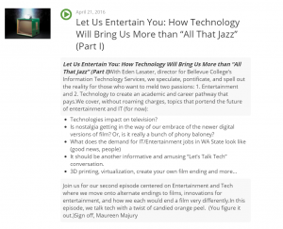

Read more here.

If you wish to contact the Center, please email Maureen A. Majury, M.Ed. at maureen.majury@bellevuecollege.edu

