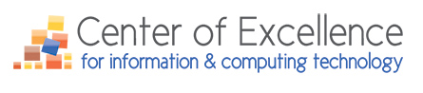

Updates & News for January 2018

The Center of Excellence for Information Technology is offering up to Nine IT Professional Development/Training Scholarships to CTC IT Faculty across Washington State

There following is the next deadline for the IT faculty professional development training scholarship applications:
- The next deadline will be Friday, January 19, 2018. The decision of who will be awarded the scholarships will be made by Friday, January 26, 2018.

IT Professional Development must take place before May 10, 2018.

The following are examples of the types of IT professional development training opportunities IT faculty could consider, if they don’t already have a training opportunity in mind.
- IBM’s THINK 2018, March 19-22, 2018, Las Vegas, NV
- Red Hat Summit, May 8-10, 2018, San Francisco, CA (Registrations open in early 2018)
- Microsoft Ignite, 2018 (Dates not finalized), USA
- Online or local in-person training is also an option for those who do not want to attend a professional development/training conference.

Click here for process details, and how to apply.

Registration for the 2018 IT Futures Summit is Now OPEN!
(It is a free event)

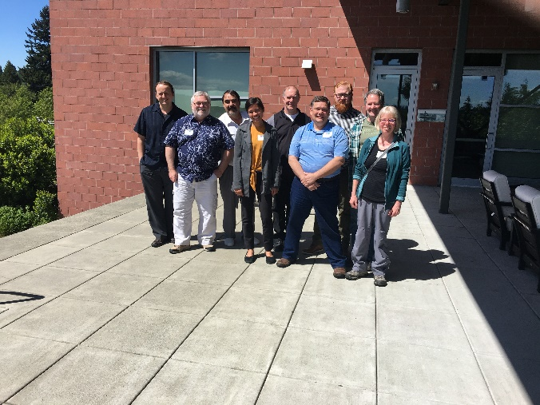
Will You be on the Team That Beats Last Year’s IT Jeopardy Winners?
Registration is now open for the Center of Excellence for Information & Computing Technology 2018 IT Futures Summit taking place Thursday/Friday, May 17/18, 2018 at the Mercer Island Community & Event Center. IT faculty from across the state are invited to attend this a 1.5-day experience. Note: For those traveling over 50-miles, travel costs will be covered by the Center of Excellence. The Summit’s agenda includes:

- Updates on CoE project and services,
- Update on the IT statewide marketing plan,
- An industry panel,
- IT Faculty Scholarship Recipient Presentations,
- Machine Learning and Robotics Presentation,
- New topics for discussion, including SBCTC updates, new BAS degrees,
- IT Jeopardy 2018 (Who will triumph?) And, yes, after a question is correctly answered, the next question is up for grabs for any of the three groups,
- Connections with industry professionals about the state of the IT (and, IT-enabled) industry,
- And, more…

State of the Gaming Industry in the King County Region (Report)

This a high-level overview of the state of the gaming industry in the King County region and includes information related to types of gaming jobs, demand for software developers in gaming occupations, competition for community and technical college (CTC) in King County from other educational organizations. Finally, there are recommendations for developing a game developer program of study.
State of the Gaming Industry in the King County Region

If you wish to contact the Center, please email Maureen A. Majury, M.Ed., Director, at maureen.majury@bellevuecollege.edu

