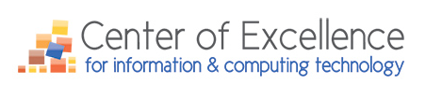
Update & News: Winter 2015

The New Year has passed and as we sit in the middle of the quarter, the Center of Excellence for Information and Computing Technology has a variety of updates surrounding its initiatives, an upcoming event, the progress made in the statewide IT program marketing plan, and the possibilities/viability of looking at developing a certificate/degree for a robotics or UAS program.

 Creating IT Futures: 2015 Summit (Free Event)

CREATING IT FUTURES: 2015 SUMMIT (REGISTER HERE)
You are invited…
Who: Up to two Information Technology or Computer Science CTC Faculty from each college (Note: A travel stipend to offset travel costs will be allocated upon delivery of receipts for faculty from Central, Eastern, North and South Western Washington to encourage attendance and engagement at this event – over 50 miles for travel is considered being eligible for reimbursement for travel ) and select IT industry professionals.
IT faculty who attended the May 15/16, 2014 IT Futures Summit will be given the two slots to attend. If faculty who did not attend that event register and those slots aren’t filled with the 2014 attendees, then their registration will be accepted in their place. Be sure to coordinate with your Academic or Workforce Administrator to ensure this attendance coordination is understood. If you want to send more than three educators from your college, please contact the Center at maureen.majury@bellevuecollege or call 425.564.4229.
What: Will be happening? This group will take up and complete issues that were addressed at the May 2014 Summit (held at the Mercer Island Community & Events Center), including:
- the six IT common courses that have been finalized, the next four for consideration, and whether or not faculty want to formalize these courses by going through the official common courses numbering (CCN) the State Board’s CCN process (Read the results from the IT Common Course Survey January 2015 here, the course descriptions have been updated to reflect the changes faculty recommended. It’s understood final changes/edits, etc. will be made at this event.)
- IT program marketing materials presentation.
- Progress on the exploratory research of state robotics/drone workforce demand, curriculum, and academic and career pathways.
- IT BAS proposals and updates on progress.
- Industry feedback on the state of the IT industry.
- Hot topics and areas of interest for the IT faculty community.
Where: Mercer Island Community & Event Center, 8236 SE 24th Street, Mercer Island, WA 98040/tel (206) 275-7609, The Mercer Room.
When: 9:30 a.m. to 3:30 p.m., Thursday, May 14, 2015 & 10:00 a.m. to 1:00 p.m., Friday, May 15, 2015
Why: Everyone has worked very hard to collaborate and create solutions that make it easier for IT faculty and students access and succeed in completing an IT program of study in the CTC system and enter the workforce prepared to meet employer needs. We need to continue our collective work together and explore and create new innovative solutions for our system.

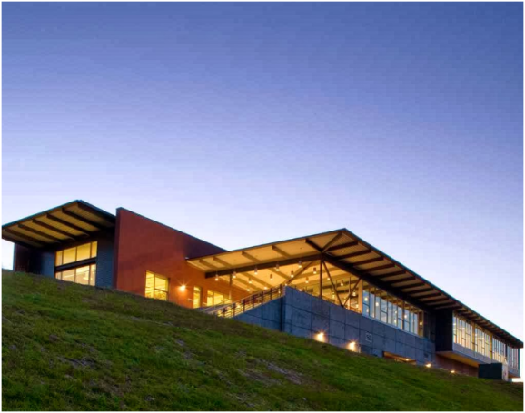 IT Common Courses: Update & Survey
IT faculty from around the state assembled in May 2014 at the Mercer Island Community and Event Center for the Creating IT Futures Summit 2014. They came to consensus on the six IT common courses they had been working on over the last two years.
- Here is a list of the final six courses, as well as the next four courses, including naming and numbering conventions.
- IT faculty will continue with IT common course work and discuss and decide whether or not to pursue the formal IT common course numbering (CCN) process through the State Board’s CCN process. A survey will be sent out ahead of time to gauge the % of IT programs at each college are willing to pursue a system-wide implementation of IT common courses for the 10 courses you have identified over the last four years.

IT Program Marketing Initiative: Our state’s CTC IT programs are accessible, affordable, provide excellent support, and are adaptable to new and emerging technologies. They provide a variety of options for students who want to pursue an IT career pathway ranging from certificates, to degrees (both two- and four-year) that need to be highlighted. As articulated by faculty from across our state during the IT Futures Summit (May 2014), awareness by students and parents about CTC IT program options is not where we want it to be.

Thus, the Center and a leadership team of IT faculty and administrators have created a plan to address this. The Center has developed, with the IT program marketing leadership team, an RFP to hire the services of a marketing/advertising firm to create an information and awareness IT program campaign.

The purpose is to ensure our state’s students, parents, and educators are aware of the wide variety of IT programs available to them. The rationale is to not only increase FTEs, but to increase the number of students getting a quality education in order to enter the workforce. The Center will be starting to develop the campaign with the successful marketing company by the end of March 2015. An update on progress will take place at the IT Summit (May 2015)

 IT Program Reviews &
IT-Applied Baccalaureate (AB) Degrees
The Center will again be performing IT program (degree/certificate) reviews at no charge to a college. One spot remains for this free service. If you are interested, please contact the Center of Excellence.

Additionally, if your college is either planning to, or already engaged in offering an IT-Applied Baccalaureate degree, the Center also can review, perform research, or offer consulting services towards that effort.

Please contact the Center with any questions, suggestions, or to request subscription to the Center’s “News & Updates” by contacting Maureen Majury, Director, at maureen.majury@bellevuecollege.edu.

