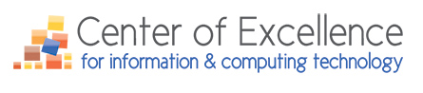

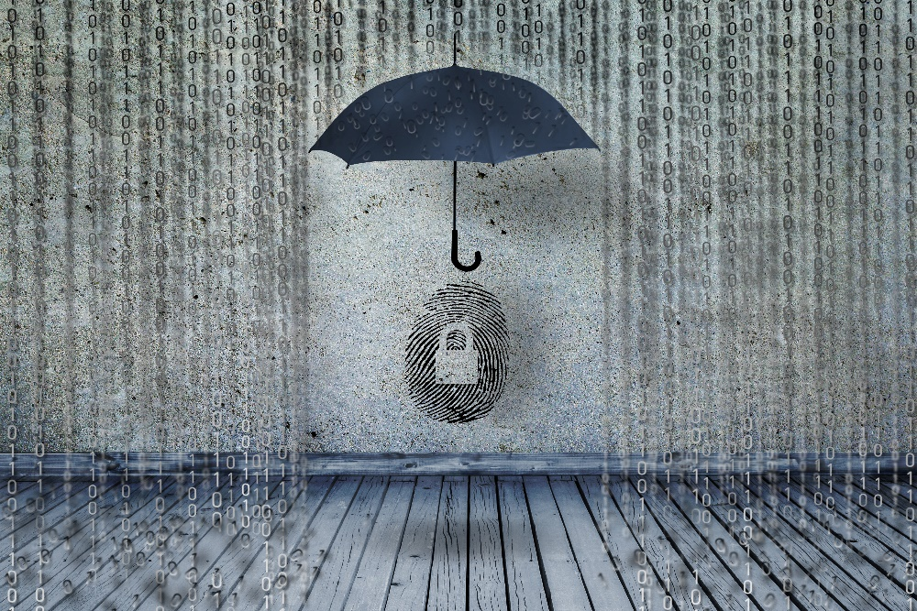

Updates & News for Spring Quarter 2018

Registration for the 2018 IT Futures Summit is Now OPEN!
(It is a free event)
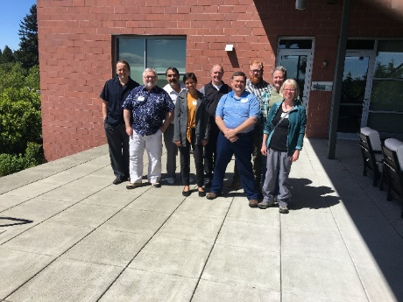
Who Will Be On The Team To Beat Last Year’s IT Jeopardy Winners?
Registration is still open, but space is filling quickly, for the Center of Excellence for Information & Computing Technology 2018 IT Futures Summit (free) taking place Thursday/Friday, May 17/18, 2018 at the Mercer Island Community & Event Center. IT faculty from across the state are invited to attend this a 1.5-day experience. Note: For those traveling over 50-miles, travel costs will be covered by the Center of Excellence.
This is an excellent opportunity for IT faculty to share and learn from colleagues across the state about what’s happening in their classrooms and their IT programs. The Center also has presentations from IT faculty about the IT conferences they attended as a Center IT Scholarship Recipient. Faculty will hear about blockchain technology, machine learning, using technology in education, quantum computing, and more from their peers. The Center will also be sharing robotics and AI curriculum with interested faculty who are considering offering a course(s), a certificate, or a degree.
The Summit’s agenda includes:
- Updates on CoE project and services,
- A presentation from Ryan Davis, CEO of the Corporation for a Skilled Workforce
- IT Faculty Scholarship Recipient Presentations,
- Machine Learning and Robotics Presentation,
- New topics for discussion, including SBCTC updates, new BAS degrees,
- IT Jeopardy 2018 (Who will triumph?) And, yes, after a question is correctly answered, the next question is up for grabs for any of the three groups,
- Connections with industry professionals about the state of the IT (and, IT-enabled) industry,
- And, more…

IT Program Reviews

The Center is now accepting applications for its IT Program Reviews at no charge to the requesting college(s). It also, as time permits, will take on additional IT program reviews, from colleges that don’t formally apply.
Since 2009, the Center has performed 60+ ICT degree/certificate reviews (including proposals for IT applied baccalaureate degrees) at no charge for Washington State community and technical colleges.
After a comprehensive review by industry professionals, a custom report summarizing the recommendations made by the industry review team, as well as provide a high-level workforce trend scan, employment trends if applicable, and possibilities for emerging trends that might influence curricular changes or developments is issued to the college that submitted an IT program, degree, or certificate for review. Workforce administrators, program chairs, or IT faculty can apply here, or contact the Center directly at maureen.majury@bellevuecollege.edu.
Projects, Services, Resource Requests
If there is a particular project, service, resource, etc. that your college would be interested in the Center pursuing, please contact the Center. The Center’s work plan for the 2018-2019 is shaping up to be a full one; however, the Center is always open to requests from your college.

Look for a new, exciting, curriculum and self-learning project for IT faculty focusing on disruptive technologies and the 4th Industrial Revolution (IR4). It will focus on IT programs can incorporate new learning modules, courses, etc. in robotics, artificial intelligence (AI), the internet of things (IoT), security (ethical hacking), web and software development, and data science. This will be an ongoing project and the Center will focus on robotics, AI, and the IoT for the 2018-2019 year.

You can read about disruptive technology in this Center PPT presentation by Maureen Majury, M.Ed., Director, from the 2017 IT Summit.

